HP Ezmeral Case Study

Business Requirement
Gartner estimates that 90% of enterprises will have containerized applications in production by 2026. These enterprise organizations are adopting containers and embracing a cloud-native micro-services architecture to accelerate the speed of application development and innovation, while also benefiting from greater efficiency and portability.
Kubernetes has emerged as the de facto open-source standard for container orchestration and is now a fundamental building block for cloud-native architectures. The vast majority of enterprise applications are still non-cloud-native, typically with a monolithic architecture and persistent data storage.
The challenge is how to run these monolithic applications in containers, without re-architecting them.
- Enterprises have a wide variety of monolithic applications that are non-cloud services
- Re-Architecturing these as cloud natives applications is time-consuming, expensive, and in many cases, not possible
- Enterprises are forced to maintain different approaches for cloud-native and non-cloud native monolithic applications.
HPE Ezmeral Container Platform is a Kubernetes-based software platform for deploying and managing containerized applications in the enterprise at scale, for both cloud-native and non-cloud-native monolithic applications with persistent data.

Challenge:
Though there is a huge market demand and HPE Ezmeral has the capability to address it, HPE is still seeing very low adoption and conversion rates. The current user experience is disconnected.
HPE realized a need to reimagine the Ezmeral container to increase adoption, and improve service levels through a more agile app delivery process, eventually leading to digital transformation through a better customer experience.

Additional challenges that need to be resolved
- Infrastructure and operations (I&O) leaders find it hard to compare the different deployment models, features, and pricing approaches because different vendors are always coming up with new solutions.
- Vendors are putting a lot of emphasis on hybrid and/or multi-cloud as a major benefit. They talk about less public cloud lock-in and the ability to move workloads from one cloud to another, but they don't explain or overstate the real-world capabilities and ROI of their solutions.
- Software and service providers are differentiating their offerings by providing more complete solutions, adding capabilities such as distributed management of multiple clusters, application life cycle integration, policy management, monitoring and security to the foundational container orchestration capabilities.

Intelligaia: HPE's CX and UX Innovation Partner Involvement

Design Sprint Workshop
Together with the HPE team, we held a Design Sprint Workshop to better understand the needs, come up with ideas and possible solutions as a group, and find interesting and engaging ways to present the research results.
We held a workshop to identify business objectives and key challenges that needed to be addressed first.
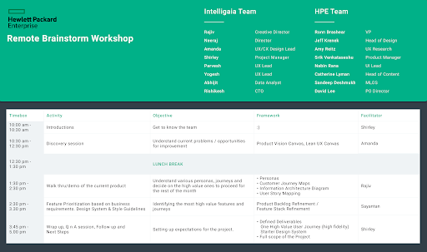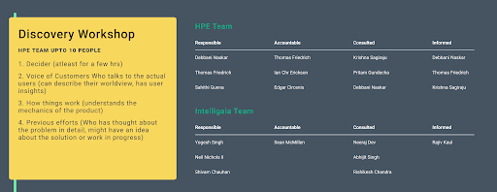

Business Goals
- Rethink the HPE Ezmeral Container Platform so that it is used by X% more people by December 20XX.
- Better service levels through a more agile app delivery process
- Digital Business/Transformation/Services
- More rapid modernization of technology
- Prevent vendor lock-in.
- Better customer experience
To encourage everyone on the team to commit to the same objectives, the sprint workshop was invaluable. The sessions were quite beneficial, and everyone contributed insightful ideas.

UX Research
Intelligaia started the research work with the in-house Kubernative team by understanding the current application's flow, personas, and journey gaps. They also did a competitive analysis.

Persona and Empathy Mapping Workshop
Based on our user-centered design approach, we started exploring who the different actors or personas are and the roles they perform in the operationalization lifecycle. Persona and Empathy Mapping workshop was the guided template framework that helped drive the personas, these personas helped HPE better resonate with its target audience and create a more human-centered design approach for the product.

Key Personas:

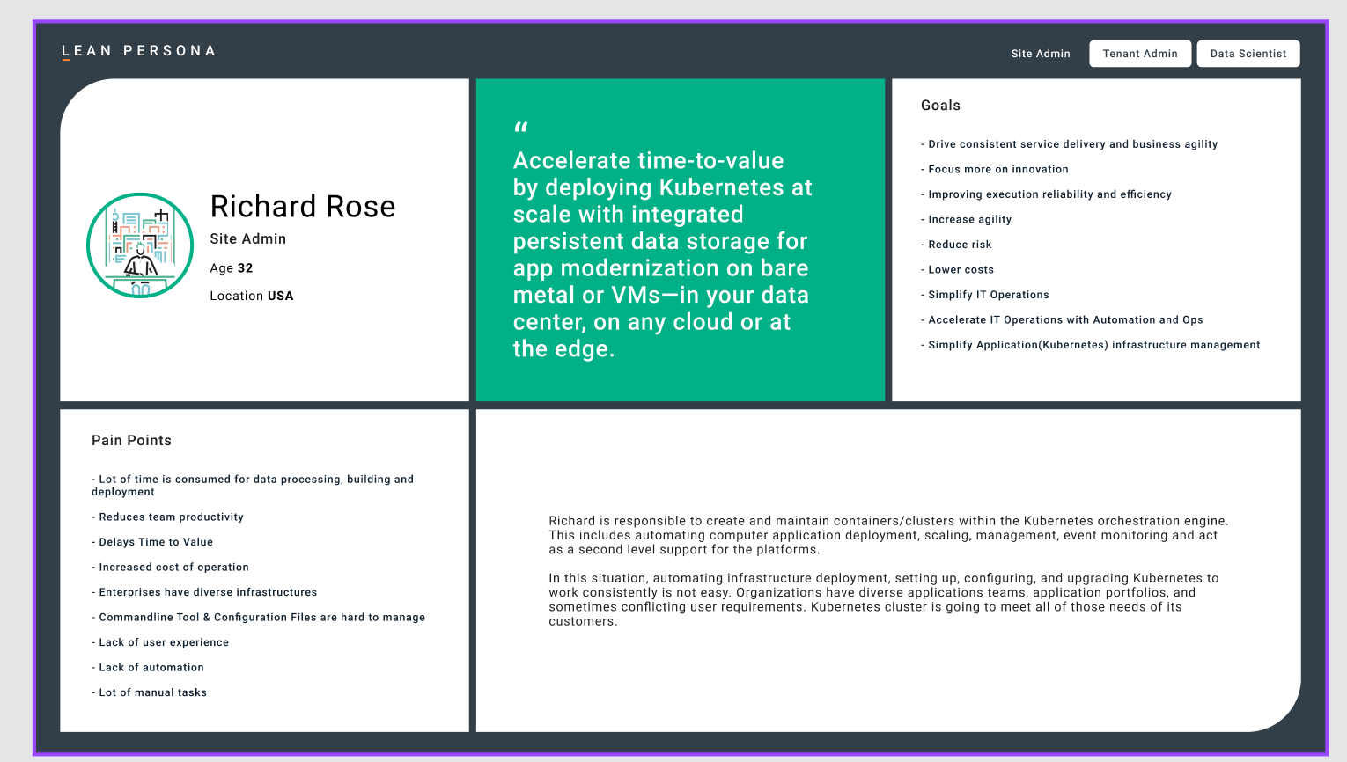
  - Kubernative/Cluster Management: Site Admin, Cluster Admin, Tenant Admin
  - Data Management: Data Engineers
  - MLOps: Data Scientist, Operations Team, and BI Reporting Team

Competitive Analysis
Helped find ways to improve. By conducting a thorough competitive analysis for product design, we gain valuable insights into our competitors and make informed decisions about the product design and opportunities to improve.
As part of our research, we also analyzed the architecture of other Kubernatives and MLOps platform competitors in the market.
- Automation & Customizability: Are the key element of MLOps, and Kubernetes offers several automation tools that may be utilized to automate ML activities. Consider supplying ML-specific tools for automating data processing, model training, and model deployment.
- Data management: Effective data management skills are essential since data is a key component of ML jobs. Provide machine learning-specific features for data processing, data labeling, and data versioning.
- Monitoring: Monitoring ML workloads is crucial for making sure the models are working as efficiently as possible and for identifying abnormalities. Consider providing ML-specific tools for monitoring model performance, resource usage, and system health.
- Integrations: ML procedures usually involve interacting with a variety of tools and services. Integrations with popular ML frameworks, data storage companies, and CI/CD pipelines should be made available.
- Documentation and training: In order to ensure that users can make effective use of your platform, it is essential to provide documentation and training materials. Consider providing ML-specific documentation and training materials that feature typical ML workflows, best practises, and troubleshooting guidance.
- API Support: Providing robust APIs can enable customers to integrate your product with other systems and tools they use. It is important to ensure that your APIs are well-documented and easy to use.
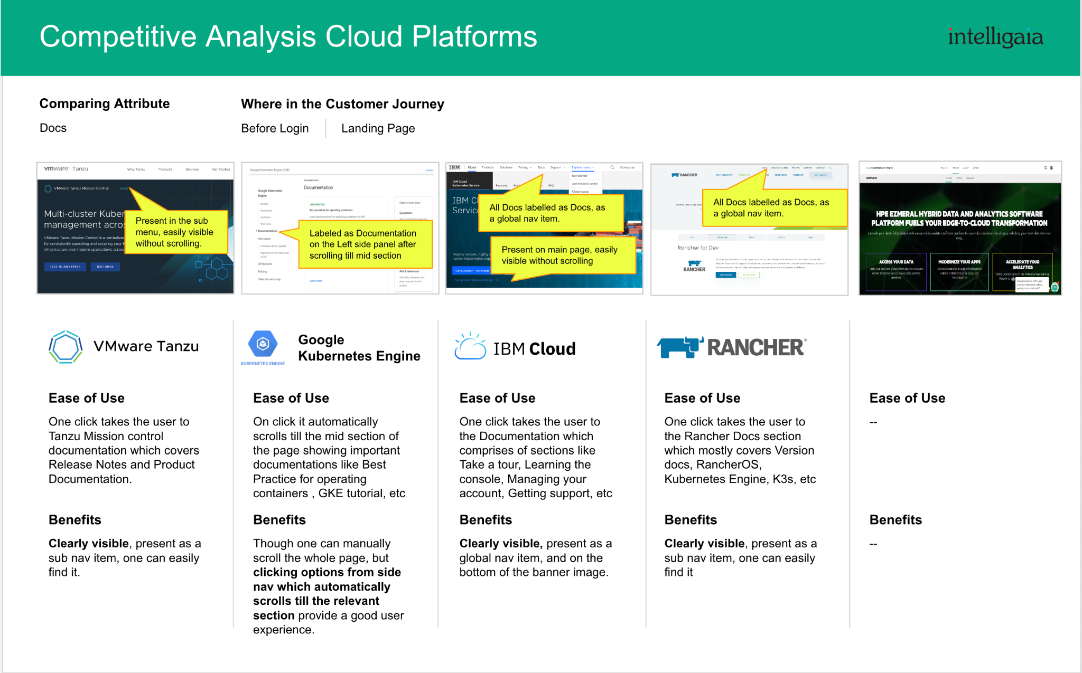
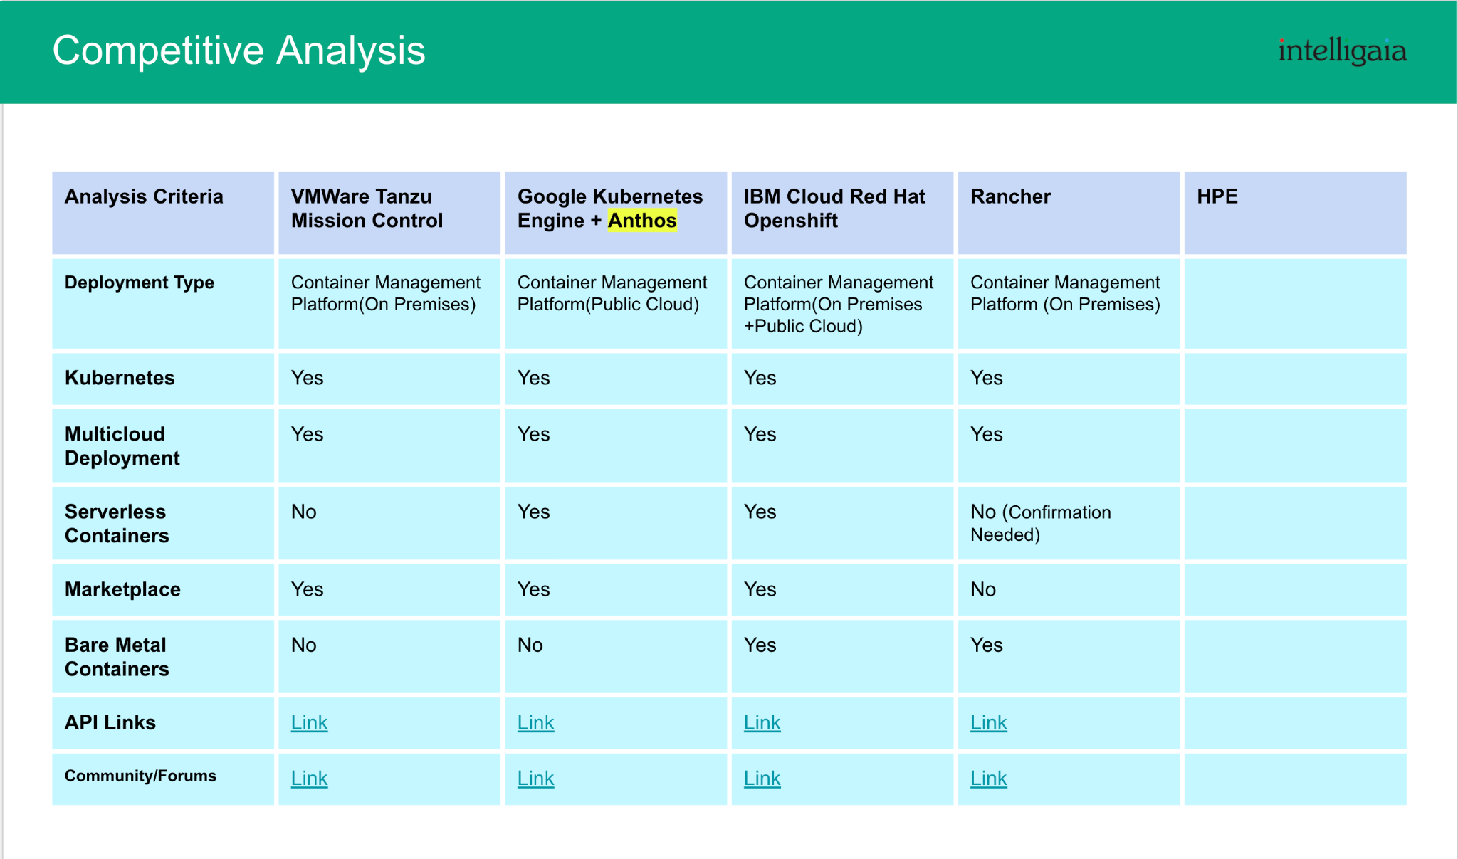

Additional research findings
Gartner reported that
- 86% of organizations are struggling with the operationalization of data science models.
- Hype Cycle for Artificial Intelligence, 2021, MLOps is currently at the Peak of Inflated Expectations and will reach the Plateau of Productivity in 5–10 years. This indicates that MLOps is a rapidly growing discipline with a bright future.
- MLOps will play a crucial role in more than 50% of data science activities by 2024, up from less than 5% in 2019. This shows that MLOps is becoming more important in current data science endeavors.
The Flexera survey showed. AWS managed options are by far the most prevalent way to manage containers, at 52%, with self-managed Kubernetes at 37%, Azure-managed at 35%, and GKE-managed at 23%.
According to Data Dog's latest Container Report, roughly 90% of organizations running Kubernetes on Google Cloud rely on GKE, and AKS is fast becoming the norm for Kubernetes users on Azure, with two-thirds of respondents having adopted it. Meanwhile, Amazon’s EKS is up 10% year-on-year and continues to climb steadily.
In the latest CNCF Cloud Native survey, 26% of respondents use managed Kubernetes services, up from 23% the year before and catching up fast to on-premises installations, at 31%. Those respondents being CNCF members may skew that number to self-managing organizations that would traditionally tinker with their own Kubernetes clusters. So the actual usage of managed Kubernetes could be higher than the CNCF survey indicates.

Value Stream Mapping & User Story Mapping
We prioritized the ideas and concepts we needed to solve first and moved forward to create a detailed Journey Map and Value Stream Mapping for the responsive persona and related roles.
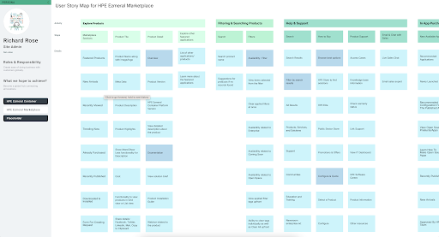
- Data Scientist: Data Ingestion and Modeling queries are the most important to address first.
- Combine MLFlow, Airflow, and ECP.
- Policy management and deployment are very important parts of administration, and if we could simplify and automate them, it would be very helpful.
- The current version does not support data orchestration, which makes it difficult for MLOps and Data Scientists to work efficiently. A lot of time is wasted on it.

To better understand the product's structure and flow, it gave a visual depiction of the connections between user stories (that give value to the user) and personas and their objectives.

Customer Journey Mapping
A visual representation of the user journey really helped identify the gaps in the customer journey, revealing the disconnected experience and task dependency between the different personas.
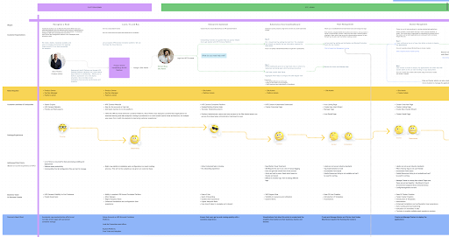

Example
- Kubernetes and Cluster Management:
  - No central location, no email notifications based on the trigger point, platform installation, and configuration require a great deal of handholding and are thus not scalable. Monitoring is difficult, and backup strategies require better implementation along with the need for rule-based triggers. Policy management has a lot of limitations.
- App Catalog is a different platform and has no integration with Tenant Management. A user has to go back and forth a lot to install an app or its dependencies. Permission requirements were missing and were not easy to manage.
- Their productivity was suffering as a result of a lack of contextual assistance, data complexity, difficult collaboration, no way to capture outcomes or even compare the performance of different models, and difficult-to-manage visualizations. These had an effect on how well the team worked, slowed things down, made it take longer to get value, and raised operational costs.
- Journey for the interconnected persona was broken
  - A Data Scientist may have 2 theories to reduce churn. To test those theories, they need to connect to a data lake, which holds most of the information that the organization possesses. They check their code-in after determining which model will be the most effective.
  - When the data scientist is done validating their model, the software engineers connect to that model registry to validate and wrap that code so that model can be effectively deployed into production. However, these links are missing, and there is no easy way to add or automate them.

Solution Concept Sketching and Creating High-Fidelity Designs
With all the insights gained through the user-centered design process, we started correlating things with the HPE Core team and started building the Day 0 and Day 10 flows for all the key personas and hero screens/flows.

Sketch Concepts
Sketches are valuable in the development of the user experience (UX) because they allow for the rapid exploration and communication of design concepts with a low level of realism. Without devoting a lot of time or energy, designers may try out several potential design solutions, compare and contrast various ideas, and hone their designs with the help of rough drawings.
Sketches helped us get the alignment towards the design solution and high-level approach.

High fidelity Mockups
High-fidelity mockups were generated to provide a more detailed and realistic representation of the final product and also helped to identify and address design issues early in the process.
We help HPE expand its design system to the next level. This also acted as their brand guide and strategy.

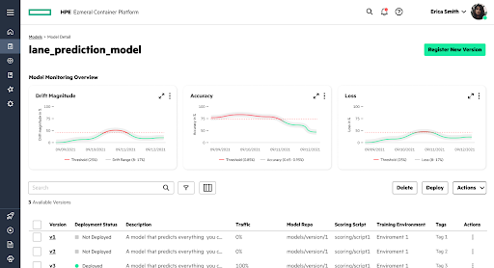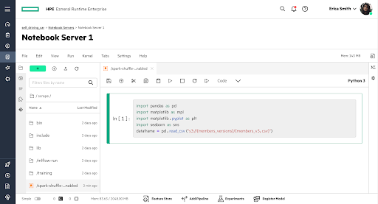
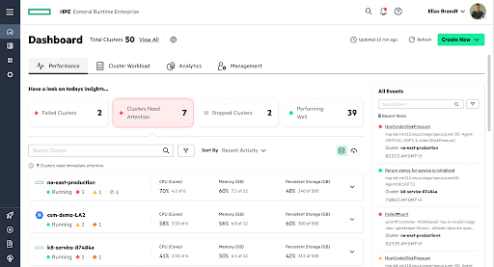
Clickable prototypes were used to breathe life into the high-fidelity mockups. This provided a clean visual journey for each persona and also helped in taking feedback from the key stakeholders.
As we progressed, the app kept expanding to the following verticals:

Components of the Solution:
- HPE GreenLake for Containers -
  - Site Admin, Cluster Admin, and Tenant Admin Cluster
  - Backup Management
  - Policy and Violation Management
  - App Management/App Workbench (Catalog, Installation, and Dependency Management)
- Data Management
  - Data Catalog: A centralized repository for storing and organizing data, making it easy for data scientists to find the data they need.
  - EzSQL: is an intuitive SQL interface for querying and analyzing data, making it easy for data scientists to explore and understand their data.
  - Analytics Fabric: Includes open-source workflow engines such as Airflow (primary) and Argo to help with data engineering and task automation.
  - DataSpace: Adding new data sources and improving visualization capabilities helpped customers better understand their data and make more informed decisions
- HPE GreenLake for MLOps
  - Spark and Livy UI: A graphical user interface for managing Spark and Livy jobs, which makes it easy for data scientists to run and keep an eye on their jobs.
  - Notebook Management
  - Enterprise source control and model repositories
  - Model Monitoring: Tools for monitoring the performance of ML models in production, allow data scientists to make informed decisions about how to optimize their models.
  - Model Serving: Tools for deploying and serving ML models in production, making it easy for data scientists to integrate their models into applications.

Result
The HPE Ezmeral platform's digital transformation was built around a centrally managed platform for Kubernative management, Data Engineers, Data Scientists, and MLOps to make administration and machine learning (ML) operations easier and more efficient. A comprehensive platform that would help data scientists and engineers manage their ML models more effectively
By streamlining app modernization, boosting data and model cooperation, refining policy administration, and providing out-of-the-box run-time security, this newest edition helps real-world customers speed up their analytics factory construction and data science activities.
Some of the key features of the new release are
- Persona-based Navigation
- PLG approach
- Time to Value Proposition
- Improved Onboarding Experience, Dashboard, Day 0 and Day 1 and Day n, All Hero Screens, and Journeys, Customizable dashboards:
- Reduce complexity - intuitive and easy to use.
- With ease, modernize legacy, non-cloud native apps.
- Reduce security risk with a secure, multi-tenant environment.
- Empower data scientists and accelerate time to value
- Solve operational risk and data gravity issues
- Advanced features for model management and deployment.
- Include tools for model training, validation, and deployment, as well as advanced features for model management and monitoring.
- Constant Integration (CI)/ Constant Deployment (CD) Pipelines
- New capabilities are tied to advancing our AI/analytics and DevOps capabilities.
- It supports a variety of use cases, including machine learning, analytics, IoT/Edge, DevOps (CI/CD), and application modernization.

The MLOps platform developed by Intelligaia was a huge success. Customers of HPE Ezmeral liked the platform because it was easy to use and had a lot of advanced features. It helps them save time and resources by automating many of the manual tasks involved in ML model management, like model monitoring and serving.
The data catalog, Spark and Livy UI, EzSQL, model monitoring, and model serving components added to the platform made it even more valuable. Intelligaia's expertise in building cutting-edge technology solutions, combined with its understanding of the MLOps space, made it the perfect partner for HPE Ezmeral.

Usability Review
Usability Evaluations were done with actual customers for the final product.

